******Annual Report**

**2018**

**Walkinstown Greenhills Resource Centre**

**16 Bridgecourt Office Park Walkinstown Avenue Dublin 12**

**Phone: 01 4198630**qqob_h2t[1][**info@wgrc.ie**](mailto:info@wgrc.ie)

**Website**: [**www.wgrc.ie**](http://www.wgrc.ie)



***Vision***

*Our vision is to work in partnership with participants, their families and their communities to create a more inclusive community in Walkinstown and Greenhills where our participants are treated as emerging active citizens with strengths and contribution to make to their own, and their community’s wellbeing.*

***Mission***

*The Mission Statement of WGRC is to empower and support the people of Walkinstown and Greenhills to work in solidarity to tackle the causes and symptoms of substance misuse and in so doing develop responses to meet the needs of the local community.*



**WALKINSTOWN GREENHILLS RESOURCE CENTRE**

Contents

Chairperson’s Report 1

Manager's Report 2

A Literature Review of Family Support Interventions 3

Demographic Overview of Local Area 14

Overview of Services 15

Service Provision 16

* Drug Misuse Service 19
* Adolescent Support Service 21
* Family Support Service 22
* Group Based Support Service 23
* Mental Health 26
* Mens Shed 28
* Young Person & Family Support Worker 29
* Strengthening Families Programme 31
* Policy & Inter Agency Work 33

Governance 34

WGRC Organisational Structure 39

Board of Directors 41

Financial Report 42

Acknowledgements 43

**The Chairperson’s Report**

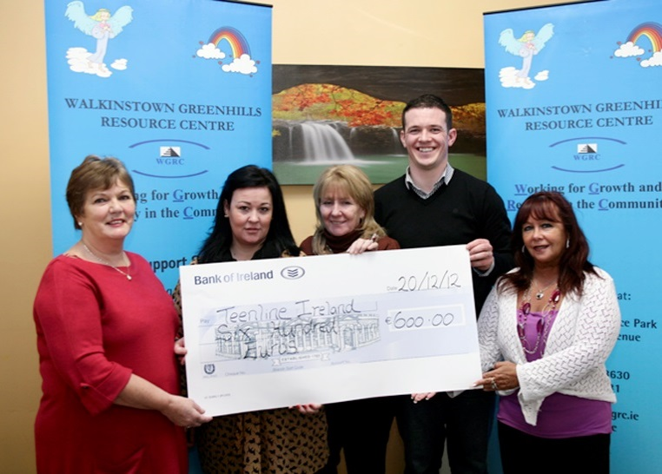Walkinstown Greenhills Resource Centre had a very productive and successful 2018. Responding to clients’ presenting needs are at the core of our work. We work with people who are vulnerable, marginalised and often from dysfunctional backgrounds with complex medical and psychiatric needs. We see a prevalence of second and sometimes third generation families with addiction problems. Our work provides us with the opportunity to break that generational cycle of addiction, through working with family members, especially mothers and their children.

Our focus is constantly on quality services to ensure the best possible outcomes for clients. Critical to best outcomes is continuous staff training and development programmes. Effective governance is essential in order to achieve WGRC’s vision that everyone should have the opportunity to overcome addiction and lead a fulfilled and productive life. This is the last year of our ambitious Strategic Plan 2015-2018. In October 2018 the Board and Staff engaged in a series of facilitated planning sessions to devise our Strategic Plan 2018-2021. The planning process gave consideration to strategic plan implementation, assessment of need, capacity to respond to service demand and assessment of Board and sub committees’ effectiveness.

I’d like to take this opportunity to thank those who support us, our donors, funders and strategic partners. On behalf of members of the Board, I also extend our thanks to every member of our team in WGRC. Our staff perform to the highest standards and carry out their work with dedication, respect and the capabilities to provide the highest possible quality standards. Our thanks also to our Manager who continues to be a strong and effective leader.

WGRC board members contribute their time and expertise on a voluntary basis and I thank each one for their guidance to me and their strong commitment to achieving WGRC’s objectives

**Bernadette Stokes**

**Chairperson,**

**Board of Directors**

**The Manager’s Report**

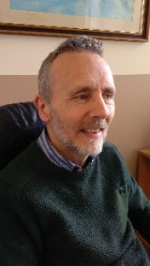In 2018 the Walkinstown Greenhills Resource Centre (WGRC) continued to deliver services to individuals and families experiencing the very many challenges that come with substance misuse and mental health difficulties. Throughout the year WGRC achieved its primary objective of providing high standards of care to our participants. In 2018 we completed our current strategic plan. Although we made good progress with implementing the plan, we were confined by the limitations and restrictions brought about by the lack of additional funding needed to support the growing demands on our services.

2018 was a momentous year as the Irish Government began the process of implementing the National Drugs Strategy- Reducing Harm Supporting Recovery - A health led response to drug and alcohol use in Ireland 2017-2025. WGRC welcomes the health led focus of this comprehensive strategy and we look forward to playing our part in its implementation. We welcome the actions arising in the strategy to minimise the harm, caused by problematic substance use, and the promotion of rehabilitation and recovery. In particular, we are delighted to see the actions, identified in the plan, to support individuals to build Recovery Capital by increasing progression options for recovering drug users.

As ever, WGRC is extremely dependent on its funding base to maintain services. State funding accounts for 95% of our total income in 2018 and this figure barely allows for adequate maintenance of our services at our current levels. Any reduction in our funding will pose a serious threat to vital frontline services. This has already come to pass with our Play Therapy programme having to cease as funding was not secured to safeguard quality service delivery. Our Mental Health Recovery programme was also curtailed due to lack of funding.

Another risk associated with funding limitations is the loss of highly trained and skilled staff members. Regrettably, the organisation lost three such staff members in 2018. In order to maintain our standards of excellence, staff retention will need to be addressed as a matter of crucial strategic importance. In response to staff expectation of wage movement after nine years of a pay and increment freeze, it is imperative that this matter is given serious attention by our funders. There is little doubt that wage movement will be a factor in future years and increased funding will be required if WGRC is to avoid losing another raft of competent staff members.

I would like to take this opportunity to thank the WGRC team – staff, board members and volunteers - whose perseverance, dedication and hard work made 2018 such a successful and memorable year for WGRC. I would like to thank also our supporters as your generosity allows us to continue to provide our recovery services and introduce new programmes to meet growing and changing demands. We look forward to strengthening our relationship with you in 2019.

**John Davis**

Manager

**A Literature Review of Substance Misuse & Family Support Interventions**

**Introduction**

Increased substance misuse in contemporary societies generally has resulted in stark and enduring problems for many families and communities (Orford et al., 2007a: Stewart et al., 2007). Research with people who had or were receiving addiction treatment found all areas of their lives had been affected by their substance use (Schafer, 2011; Copello et al., 2006). This included family disruption and violence, unemployment and poverty, martial instability and breakdown, physical and mental ill-health (~Schafer, 2011). Moreover, those living with someone experiencing alcohol and/or drug problems are likely to suffer increased risk of physical and mental ill-health, domestic violence and intimidation, family breakdown, poverty and indebtedness, and risk of child maltreatment and neglect (Schafer 2011; Orford et al. 2007; Duggan, 2007; Copello et al., 2006).

Traditionally, drug treatment and rehabilitation programmes have focused solely on substance misusers, with family members receiving little if any attention (Copello et al., 2006). However, over recent decades, programmes increasingly have included a ‘family component’, reflecting a growing recognition of the important roles families can play in the treatment and recovery of addicts (Orford et al., 2007; Copello et al., 2006). This chapter reviews literature relating to substance misuse and support interventions in order to report the efficacy of drug and alcohol family support services. It begins by outlining the risk and protective factors that shape substance misuse before discussing outcomes for substance users and their families. The chapter also outlines current drug and alcohol policy, the roles families may have in treatment and recovery, and some of the needs of affected families seeking support.

**Substance Misuse: Risk and Protective Factors**

The prevalence of substance use in contemporary societies has dramatically increased over recent decades. Ireland, in particular, has one of highest levels of alcohol consumption in Europe (Health Research Board, 2014) in 2010, for example, 11.8 litres of pure alcohol was consumed for every adult over the age of 15 (Health Research Board, 2014). Moreover, problem alcohol use in Ireland stood at 8,336 cases seeking treatment in 2012 up from 7,940 in 2008 and is linked to a variety of medical conditions and negative effects including liver cirrhosis, various cancers, road accidents, and mental ill-health and suicide (Health Research Board, 2014).

Individual, family, and community factors and their interrelationship are associated with engagement or not in alcohol and/or drug use (Becona et al., 2012, Arteaga et al., 2010). Risk factors increase the likelihood of engaging in adverse activities such as substance use (Hemphill et al. 2011). Protective factors offset and/or decrease the probability of harmful activities and behaviours (Hemphill et al. 2011).For instance, adolescence is recognised as a “peak period” for initiation and use of alcohol and drugs (Hemphill et al., 2011). A World Health Organisation study of 16,010 Irish children in 2010 found over half of boys (53%) and girls (52%) aged 15 to 17 years had been drunk at least once (cited in Department of Education and Skills, 2014).

Moreover, the European School Survey Project conducted in 2011 indicates almost three-quarters (73%) of Irish 15 and 16 year old students had consumed alcohol in the previous 12 months (cited in Department of Education and Skills, 2014). Palmer and O’Reilly’s (2008 cited in Department of Education and Skills, 2014) study of second level and post leaving cert students aged from 14 to 19 found the average age which students first used alcohol was 13.4 years. In addition, half of students used drugs – cannabis (41%), inhalants (30%), poppers (17%) and cocaine (11%) – with the average age of first drug use being 14.5 years (Department of Education and Skills, 2014). The National Advisory Committee on Drugs (2010 cited in The Department of Education and Skills, 2014) also reports significantly increased levels of substance use among early school leavers in comparison to school-going adolescents.

Alcohol use in adolescence is associated with greater risk of engaging in harmful behaviours such as drug use, drink driving, risky sexual behaviour, antisocial activity and violence, and low educational achievement and work performance (Arteaga et al., 2010; Spoth et al., 2009). Adolescent substance misuse (alcohol and drugs) also can lead to long-term physical and mental ill-health, substance dependency, and disturbed family and social relationships (Hemphill et al., 2011).

Alcohol misuse, dependency and related problems in adulthood frequently are related to the early commencement of drinking and the regularity and the scale of intake during adolescence and young adulthood (Holmila et al., 2010). Research in the United States US), for example, suggests substance misuse in young adulthood (18 to 26 years) disrupts later adult development (Stone et al., 2012). This “important developmental period” in which adult roles and responsibilities are determined, where relationships are established, training and education completed, and careers forged, is influenced by one’s substance use (Stone et al., 749). Failing to accomplish adult roles and responsibilities in this period due to substance misuse often is reflected in continuing risky behaviour, criminality, increased substance misuse and dependence, financial insecurity and poverty, failure to establish meaningful and lasting relationships, and deteriorating mental health (Stone et al., 2012).

**Parenting and Family Factors**

Research strongly links disrupted family relations with alcohol and drug misuse (Becona et al., 2012; Schafer, 2011; Stewart et al., 2007 Sanders 2000). For example, recent estimates (Rhodes et al., 2010) indicate approximately five million UK citizens were dependent on alcohol and/or drugs. According to Rhodes (2010) these figures suggest at least 8 million people and 2 million children are living in families affected by substance misuse. Studies also identify adolescents at risk of becoming involved in substance use are most likely to grow up in families that are unstable and where parenting had been disrupted (Becona et al., 2012; Rhodes et al., 2010; Orte et al., 2008). Adverse or disrupted experience in childhood including maltreatment or neglect, parental separation, lone parenthood and divorce all increase the risk of substance misuse in adolescence and young adulthood (Arteaga et al., 2010).

Children growing up in families affected by substance misuse are more at risk of being a victim of physical, psychological/emotional and sexual abuse (Orford et al., 2007, Capello et al., 2006). Much literature argues that substance misuse by a parent(s) diminishes parenting, the capacity to provide a nurturing environment and is inherently damaging to families (Rhodes et al., 2010; Barnard and McKeganey, 2004; Sanders, 2000). Cleveland et al. (2008), for example, identify parental substance misuse, poor parenting and marital/family conflict as important risk factors influencing child/adolescent problem behaviours including substance misuse. Barnard and McKeganey (2004) also report a strong association between parental drug use and child neglect. They argue a parent/s preoccupation with satisfying personal drug and/or alcohol needs significantly weakens their capacity to provide emotional support and consistent guidance (Barnard and McKeganey, 2004). Parents misusing drugs supervise their children less, engage in punitive forms of discipline and are less likely to positively input into the child’s/young person’s life according to their research.

Orte et al. (2008) argue protective factors impacting positively on children’s behaviours include positive parent-child relationships, positive methods of disciplining children, adequate parental supervision, and communication of positive and healthy values and expectations. However, most dependent drug users tend to be young adults and many are parents (Stewart et al., 2007). For example, nearly 300,000 children in England and Wales and over 1.5 million children in the United States were cared for by drug dependent parents according to Stewart et al.’s research (2007). In families where a parent (or parents) may be experiencing substance use problems, the protective influence of families can diminish and children become more at risk of becoming involved in deviant behaviours (Orte et al., 2008). Schafer (2011) argues, children of alcoholics are at an increased risk of alcoholism and its attendant problems including depression, antisocial behaviour and drug misuse. Her research with recovering substance misusers found a majority of research participants had experienced chaotic childhoods due to parental substance misuse.

Moreover, Barnard and McKeganey (2004) cite several studies (Kandel, 1990; Dore et al., 1996) that suggests children of parent(s) experiencing substance misuse problems tend to be less obedient and frequently were assessed as aggressive. Such children may have a propensity to be withdrawn and more likely have problems making and maintaining positive peer relations and less able to adjust to social norms and protocols (Barnard and McKeganey, 2004). They also argue children of drug dependent parents tended to have problems with hyperactivity, inattention, higher rates of emotional and behaviour problems in comparison to those in regular family situations (Bernard and McKeganey, 2004). They also cite research (Tyler et al., 1997) that suggests children with parents who misuse substances are more vulnerable to family break-up.

**Family and Extended Family**

The impacts of substance misuse on families in general are difficult to define with accuracy or consistency (Copello et al., 2010; Duggan, 2007). Until recently, most support services prioritised individual treatment and support to substance misusers (Copello et al., 2010). Also, most do not collate regarding substance misusers’ family circumstances according to Copello et al. (2010). However, as Schafer (2011:136) argues, substance misuse by family members affects all behaviour within that family system. Much research (Schafer, 2011; Parliament of the commonwealth of Australia cited in Copello et al., 2010; Rossow and haauge, 2004 among others), for example, found relatives of problem drinkers experience a range of personal, social and economic harms including harassment and the fear of or actual violence and/or psychological abuse, having property damaged or stolen, loans and debts, loss of income, homelessness, and a heightened risk of ill-health.

Several studies (Schafer, 2011; Copello et al., 2010) argue living with a relative who is experiencing alcohol and/or drug problems is extremely stressful. Copello et al. (2010), for example, link the adverse effects living with a close relative who has a serious substance use problem to the stresses experienced by those who have a relative who is disabled or has a serious illness. Orford et al.’s (2010) review of research conducted in several countries over two decades found among the most stressful experiences identified by those living with a relative who has a serious alcohol and/or drug problem was that their relationship with that relative became disagreeable and frequently aggressive. Relatives with substance use problems regularly were described as often verbally abusive and in some cases physically violent (Orford et al. 2010). Research participants complained of deceitful and domineering substance misusing relatives who often were intensely critical of other family members (Orford et al. 2010). Alternatively, they were described as isolating themselves and being uncommunicative and withdrawn (from family life) (Orford et al. 2010).

Duggan (2007) highlights stress related to having a drug-using relative has serious health impacts. She cites a UK study (Orford et al. 2000) which suggests “every problem drug user will have a significant negative impact on the well-being of two other family members such that they require primary care consultations” (Duggan, 2007: 21). In addition, conflicts over money and possessions generate much anxiety and uncertainty for relatives of someone who is excessively drinking or using drugs (or both) (Orford et al. 2010). Participants in Orford et al. (2010: 46) research described failing to pay rent and/or contribute towards family expenses, possessions sold in order to fund alcohol and drug needs, pressure to give or lend money to a substance misuser as problems causing “great discomfort” and resentfulness towards the family member in question.

Moreover, Adfam, the UKs national umbrella organisation working with families affected by drug and alcohol, reports families are extremely vulnerable to illegal money lenders if a significant portion of household income is spent servicing a family member’s alcohol and/or drug needs (Adfam, 2011). This can result in families accruing large and often unmanageable debts with unscrupulous lenders and so less money for other household and family needs-paying other bills, buying healthy food, education, and transport, etc. (Adfam, 2011). Adfam’s (2011) research also indicates in many cases parents of someone experiencing substance use problems may assume the caring responsibilities for their grandchildren. Many, themselves on low incomes or pensioners, struggle under the strain of caring for children without parental support (Adfam, 2011). Irish research of grandparents involved in caring for the children of their drug addicted children (Family Support Network, 2004 cited in Duggan 2007) identified a general sense of helplessness and isolation among those studied.

The family support network (O’Leary, 2009) reports intimidation related to drug-related debt may include threats, physical and sexual violence, and damage to the family home/property. In order to pay off debts of substance using relatives, family/extended family members often have to use their own resources and, in some cases, become involved in illegal activity including selling drugs (O’Leary, 2009). In addition, money owed to drug dealers and/or lenders frequently is used to exert social control over the families affected by drug/alcohol misuse (O’Leary, 2009). Research conducted on social housing estates in Dublin city (Jennings 2013; Kearns et al., 2013) found intimidation and drug debt intimidation can result in families and communities becoming victims of violence and prolonged and sustained antisocial behaviour. Jennings (2013: 11) found intimidation negatively impacts whole communities “spreading of fear; feelings of being helpless and isolated, reduced quality of life, and negative mental and physical health of residents”.



**Family Support and Substance Misuse**

Support services have transformed greatly over recent decades. In many countries including Ireland, the reconfiguration of support services had led to increased implementation of preventative interventions merging welfare/treatment and protection and active support of families in need (Dolan et al., 2006). Generally, family support interventions are integrated programmes that combine services (including statutory, voluntary, community and private sector agencies and organisations) in promoting and protecting the health, wellbeing and rights of children, young people and their families (Dolan et al., 2006). Programmes target those who are vulnerable or at risk, reinforcing positive informal social networks and family functioning (Dolan et al., 2006; Walters and Byrne, 2004).

Recognition of the need to support families who are affected by substance misuse has increased at policy level. The National Drugs Strategy 2009-2016 (NDS), for example, recommends “greater links” between service agencies (e.g. in youth, education and child and family support) that work with at-risk families (NDS 2009-2016:27). The strategy argues better partnership links “are essential to ensure that additional services are provided that complement those already provided” (NDS 2009-2016: 33). In particular, NDS 2009-1016 consider closer co-operation between statutory and community/voluntary agencies and organisations as vital if drug prevention goals are to be achieved. Agencies and organisations identified by the NDS 2009-2016 include An Garda Siochana, the Office for the Minister of Children and Youth Affairs (OMCYA), the HSE and relevant agencies from the voluntary and community sectors (particularly youth organisations). This requires increased awareness, co-ordination and partnership, and involves:

“ …well- developed inter-agency working, with all involved needing to be clear of their own roles and knowledgeable on the roles of others. In assessing the level of risk involved, the overall environment incorporating individual development, parents, peers, school and community would all be factors” (NDS 2009-2016: 27)

Much research points to the benefits of including the support of family members in programmes to prevent and treat substance misuse. Sanders (2000:390), for example, suggests family support is a “significant predictor” of positive outcomes in efforts to adjust behaviours of children and adolescents who may be at risk or engaging in substance use and antisocial behaviour. Barnard and McKeganey (2004) also recommend incorporating strong family support in treatment programmes for substance misusing parents. This may help in maintaining “family routines”; for example, as such support may help mediate negative outcomes for children (Barnard and McKeganey, 2004: 555). They argue that alongside supporting treatment of a family member’s substance problem, interventions should aim to address the interaction of all risk and protective factors impacting the lives and development of affected children (Barnard and McKeganey, 2004). Addressing risk factors and strengthening protective supports (in conjunction with parent(s) treatment programme) may lessen the likelihood of children developing negative behaviours and/or other issues. This is especially important as a child’s problems are likely to be determined by interaction (or absence) of multiple risk and protective factors (Barnard and McKeganey, 2004).

The UK’s Adfam organisation, however, identifies barriers that obstruct or hamper relatives of substance misusers in accessing support (Adfam, 2010). Barriers include a low level of awareness among families of their own needs, fear of being stigmatised or labelled, services treating only the substance misuser, and simply that the service is not available in their community. A key challenge according to Adfam (2010: 2) is that drug and alcohol misusers are “seen in the vacuum of their own substance use” instead of their substance use recognised as part of “a set of complex problems” being experienced by users and their family. Programmes need to consider not only the substance use but the wider context of the service user (Adfam, 2010). In addition, support should be a part of a “whole systems approach” where agencies respond flexibly and employ effective partnership processes in addressing the needs of both users and families (Adfam, 2011: 3).

**Family Focused Programmes**

There is increasing evidence of the significant support – emotional and financial – families (and other relatives and frieinds) provide to relatives who are experiencing problems with substance misuse (Copello et al., 2010). Copello et al. (2010: 67) suggest family members “are frequently unpaid and unconsidered resource” providing care and support (including financial) to relatives who drink excessively and/or misuse substances. They argue that incorporating the families and social networks of substance misusers into treatment programmes can positively influence the direction substance use problems take, improve outcomes and reduce harms for families (Copello et al., 2006). In addition, providing support directly to families can reduce costs and extend resources in addition to keeping substance misusers in treatment for longer (Copello et al., 2010).

Family Focused Programmes (FFP) have been broadly categorised in three ways: (1) programmes that work with family members and other relatives to support a substance misuser’s entry into treatment, for example, parenting programmes (Copello et al.,)2006); (2) programmes that focus on a relative’s substance problems and engage family members in their treatment and recovery (Orford et al., 2007a); and (3) programmes that respond specifically to the needs of family members, for example, Alanon family groups, the 5-step approach (Orford et at., 2007b). Programmes utilise a variety of family treatment approaches including family therapy, couples therapy, parenting information and advice, and various pro-social and behavioural therapies and methods (Orford et al., 2007b) What is evident in much literature, however, is that families and the contexts in which substance misuse occurs are diverse and may require a variety of support structures and services.

**Parenting and Childcare**

Parenting and childcare support are considered of great importance in the treatment and management of substance misuse (Stewart et al., 2007). According to Midford (2009) programmes to divert young people from substance misuse often aim to reinforce and capitalise on the significant influence parents have on their children’s behaviour by enhancing parenting skills and strengthening family relationships. Alongside treating a substance misusing parent(s), many FFPs target children and young people in order to strengthen protective factors and reduce factors that place them at increased risk (Orte et al., 2008).

The Strengthening Families Programme in the western region, for example, seeks to enhance resilience and reduce risks for families by providing services to increase parenting skills, improve family relationships and aid youth development (Sixsmith and D’Eath, 2011).

According to Orte et al., (2008), multi-component interventions providing support for substance users and their children can achieve greater outcomes in terms of improved family relationships and cohesion, parental involvement in children’s lives, and family communication, than programmes focused solely on substance users (Orte et al., 2008) They cite the (Spanish) Family Competence Programme (FCP) as a family focused drug treatment intervention. FCP combines a social and life skills course for children, a parental skills course and a family-centred course integrating the knowledge and skills learned by parents and children (Orte et al., 2008). A key factor in achieving positive outcomes were the high retention rates observed in FCP. This was important, according to Orte et al. (2008: 255) as “one of the main problems facing drug prevention programmes is the loss of participants and/or a decrease in service user interest and motivation”. They found children’s involvement and interest in their parents’ recovery encourages parents to maintain involvement in programmes (Orte et al., 2008).

**Child Welfare and Protection**

Copello et al. (2006) suggest alcohol and drug treatment/rehabilitation programmes incorporating family support provide a child welfare and protective focus and can lead to improved outcomes in terms of treatment and recovery. They agree FFPs improve spousal relationships and family functioning and reduce inter-personal violence amongst other harms (Copello et al., 2006). This is important as substance misuse (as referred to earlier) rarely occurs in isolation and has many interconnecting factors of which substance misuse is one.

A challenge for adult-oriented programmes is that many substance misusing parents, particularly mothers, do not engage with services or seek treatment because of the fear their children may be taken into care once addiction problems are identified (Rhodes et al., 2010; Stewart et al., 2007; Barnard and McKeganey, 2004). Barnard and McKeganey (2004) suggest programmes need to employ strategies that help alleviate such anxieties if they are to encourage wide service user engagement. For example, an evaluation of the Focus on Families programme (Catalona et al., 1999 cited in Stewart et al., 2007) demonstrated it is possible to engage methadone patients and their children in family-focused interventions through combining family therapy and training with case management home visits. Parents using the service reported reduced drug use and family conflict within 12 months of involvement in the programme in comparison to those receiving standard treatment (Stewart et al., 2007). However, as Barnard and McKeganey (2004) caution, strategies to improve access and engagement need to coexist with maintaining a strong focus on the welfare and protection of the children of substance users.

**Family Focused Programmes**

While a paucity of programmes supporting families affected by alcohol and drug problems is evident (Harwin 2010; Orford et al., 2007), several intervention techniques do, however, focus primarily on supporting the needs of family members. For example, Community Reinforcement and Family Training (CRAFT) (Meyers et al., 1999 cited in The Alcohol, Drug, Gambling and Addiction Research Group, 2010), the pressures to Change Approach (Barber and Crisp, 1995 cited in The Alcohol, Drugs, Gambling and Addiction Research Group, 2010), and the 5-Step Method (Copello et al., 2010), all provide support to affected families.

The 5-Step Method, in particular, is specifically focused towards supporting family members in their own right. The 5-Steps include (Orford 2007: 31): “listening non-judgementally; providing information (e.g. about drugs or dependence); counselling about ways of coping; discussing increasing social support; and considering further options for help and support”. The method is based on Stress-Strain-Coping-Support (SSCS) Model which takes the view that:

* Family members are seen as experiencing significant stress;
* Family members need help and support in their own right;
* Family members can sometimes offer important support for the user of substances and other family members affected; and
* The model on which the 5-Step Method is based is essentially about normal people dealing with highly complex and challenging circumstances (Copello et al., 2010).

According to Harwin (2010:180), research indicates programmes using the 5-Step Method “reduce family members” psychological and physical symptoms (before they may become deeply entrenched) and helps promote more effective coping strategies”. Moreover, the UK’s Alcohol, Drugs, Gambling and Addiction Research Group (ADGARG) (2010:180) suggests programmes build on the “positive resources” that families possess. In contrast to individual therapeutic treatments, which often have little regard or use for the influence affected families may contribute to a relative’s recovery or indeed, interest in supporting the needs of families members in their own right, 5-Step interventions aim to build and strengthen affected families using practical and inclusive methods (ADGARG, 2010).

For example, 5-Step programmes provide opportunities for family members to discuss treatment options and acquire knowledge of the services and support that may be available (ADGARG, 2010). This is important as it “provides opportunities for issues such as family violence to be brought out and responded to” (AGGARG, 2010: 206). Likewise, Irish research into the experiences of families of heroin users and support services reported families are “often trapped between a lack of information on what help is available and how to access it” (Duggan, 2007: 11). Moreover Duggan (2007: 11) found families seeking support for family members often struggle with complexity of accessing services given variety of stand-alone agencies.

Also important is that the third step in the 5-Step process clarifies the advantages and disadvantages of any “possible coping action” and discusses these options with relatives

(ADGARG, 2010: 206). Consequently, relatives are “calmer and less emotional, less aggressive but more assertive, in the face of a relative’s alcohol or drug misuse, and this has been effective in reducing tension” (ADGARG, 2010: 206). Moreover, programmes utilising the 5-Step model provide opportunities to speak with someone outside the family unit i.e. practitioners, about problem drinking and drug misuse; problems that are often hidden within families (Copello et al., 2010). Harwin (2010) also suggests because FFPs are evidence-based and typically brief and flexible they may be attractive to policy makers as a way to address major gaps in current service provision in regards to drug prevention and treatment services (Harwin, 2010).

However, Harwin (2010) cautions that the effectiveness of FFPs in addressing “heavy end cases” that may involve multiple risks, for example, domestic abuse (physical, psychological and sexual), criminal and poverty, is not known (Harwin, 2010: 181). In families where serious mental health or child protection concerns are present, long-term intensive support and monitoring remain the most appropriate responses (Harwin, 2010; ADGARG, 2010). For example, findings from the Roscommon Child Care Case (2010) indicate information provided to support services from relatives concerning parental alcohol misuse and the negative effects for their children was inappropriately and/or inadequately responded to. This also demonstrates the need for service co-ordination and effective partnership.

**Summary**

Substance misuse is associated with negative impacts for individuals and also the families in which they live. Literature indicates the effects of excessive drinking and/or substance misuse includes family disruption and violence, unemployment and poverty, marital instability and breakdown, breakdown, physical and mental ill-health. Some substance misusers may experience chaotic childhoods due to parental substance use and strong associations between parental drug and alcohol use and child neglect are reported. Moreover, substance use in adolescence is associated with greater risk of engaging in harmful behaviours such as drug use, drink driving, risky sexual behaviour, antisocial activity and violence, and low educational achievement and work performance.

Literature strongly links disrupted family relations with alcohol and drug misuse. In addition to causing distress and threatening the wellbeing of family members, the destabilising effects of living with a substance misuser on a family unit may weaken coping mechanisms including gaining support from others. Relatives of problem drinkers can experience a range of personal, social and economic harms. These harms may include: harassment and fear of or actual violence and/or psychological abuse; having property damaged or stolen; loans and debts; loss of income; housing problems and homelessness, and a heightened risk of ill-health.

Literature also highlights benefits of including families and social networks in programmes to prevent and treat substance misuse. Family-focused responses may positively influence the direction substance use problems take, improve outcomes and reduce negative effects for families. A key challenge in drug and alcohol services is treating substance misuse/addiction as part of a set of complex problems being experienced by users and their family and not solely as a problem for individual misusers. Support should be part of a whole systems approach where agencies respond flexibly and employ effective partnership processes in addressing the needs of both substance users and families.

Family-focused drug intervention programmes work with relatives in several ways to support substance misusers. Programmes may enlist a family’s help with a relative’s entry into treatment, focus on a relative’s substance problems and engage family members in their treatment and recovery, and in some cases, programmes respond specifically to the needs of family members. Family-focused interventions are likely to improve spousal relationships and family functioning and reduce inter-personal violence.

Children’s involvement and interest in their recovery can be particularly helpful as it may encourage parents to maintain involvement in treatment and thus help mediate negative outcomes for all family members. Alongside supporting a family member’s treatment and recovery, programmes should aim to address the interaction of all risk and protective factors impacting the lives and development of affected children. In addition, research suggests family-focused interventions provide opportunities for family members to discuss treatment options and so acquire knowledge of the services and support that may be available. Help accessing drug treatment and rehabilitation services is considered vital if families affected by substance misuse are to receive effective and efficient support.

**A Demographic Overview of the Local Area**

The Dublin 12 postal district is the locality which marks out the catchment area of the Walkinstown Greenhills Resource Centre. This geographical area is located on the south side of Dublin City and stretches from a section of the central district of Dublin to where it meets the suburban areas of Dublin at the foothills of the Dublin Mountains. It includes the localities of Drimnagh, Crumlin, Walkinstown, Greenhills, Kimmage and parts of Terenure and Templeogue Limekiln. The Dublin 12 area is served by the two sectors within the Health Service Executive Dublin South Central Mental Health Service.

Within the Dublin 12 area there are a number of premises and centres from which different mental health services and community supports are provided. These include a wide variety of therapeutic, counselling and group support services as well offices of the members of the wider multi-disciplinary mental health team. Within the area are also found Day Hospital services, the Home-Based Treatment service, the Psychiatry of Old Age Team and the Mental Rehabilitation Team. The services are not static but continue to grow and develop.

An analysis of census data compiled for the Dublin 12 Local Area Drug Task Force and reported in its Strategic Plan 2016-2019 (D12LADTF, 2016) reveals that the Dublin 12 population totals approximately 55 thousand residents living in over 21 thousand households.

The demographical breakdown of the area varies between the different districts, some with higher than average populations of older people or younger people, and some with higher than average numbers of lone parent households. Rates of unemployment vary from one neighbourhood district to another and are spread unevenly across the total geographical map of the area.

Certain districts within the catchment area record educational levels in line with or higher that the national average but other districts reveal low rates of primary school completion. The increasing diversity within Irish society is reflected in some neighbourhood districts but the general population of this catchment area was recorded as predominantly White Irish in the 2011 Census figures. Average household incomes varied considerably from one district to another within the area and certain districts are economically disadvantaged within the national context.

Overall, the profile of the Dublin 12 catchment area is, therefore, subject to variation from one neighbourhood district to another. It can be concluded that the total geographical area encompasses a diverse and varied demographic landscape which includes both advantaged and disadvantaged districts near proximity to each other as well as concentrations of older people, younger people, lone parent families, unemployed adults, and new migrant populations within some Dublin 12 neighbourhoods.

**An Overview of Services in 2018**

**Introduction**

The WGRC is a community based voluntary organisation whose mission is

*"........to empower and support the people of Walkinstown and Greenhills to work in solidarity to tackle the causes and symptoms of substance misuse and in so doing, develop responses to meet the needs of the local community".*

The organisation is staffed by a team of highly professional and qualified personnel. WGRC provides a range of services to those with alcohol / substance misuse problems, those indirectly affected by substance misuse and those with broader mental health difficulties. Our aim is to provide a safe and confidential environment where the service user has an opportunity to work towards living a more satisfactory and productive life.

In this year 248 people from the surrounding community benefitted directly from engagement with WGRC services. For example, 167 clients engaged in one-to-one counselling / psychotherapy sessions; the majority sought help in dealing with their addiction or substance misuse, others sought help for a range of mental health issues such as bereavement, separation, stress, anxiety and loss.

A further 81 service users were provided with support through group interventions under the headings of Family Support, Well Connected- Metal Health, Mindfulness, Womens Creativity Group and the Mens Shed. In addition, we provided some new services in the form of Adolescent Support and the Young Person and Family Support Work Initiative. These services are very much in the early stage of development and their continuation will be contingent upon securing sufficient resources. Information, advice and support were provided to local services, schools and community groups.

**Service Provision**

Figure 1 –Participant Statistics 2018

81 Participants attended group sessions

167 Participants attended 1-1 appointments

141 Participants were new to the service

248 Participants used our services in 2018

**Service Provision**

|  |  |
| --- | --- |
| Problem Drug/Alcohol users | Based on information gathered via assessment and one-one sessions in 2018 |
| Number of cases treated for problem drug/alcohol use  Number of persons availing of support services | 114  134 |
| Number new to the drug / alcohol service  Number of previous participants  Number new to the support services  Number of previous participants | 85  29  56  85 |
| Gender | 52% Female  48% Male |
| Main source of substance abuse  Number useing more than one substance | Alcohol & Drugs 48%  Drugs 37%  Alcohol 15%  68 |
| Main support service availed of by the participant | 25 Concerned Person 10%  114 Substance Misuse 46%  72 Mental Health 29%  12 Advocacy 5%  16 Adolescent Support 6.5%  9 Other 3.5% |
| Average age of service users | 42 |
| Group Based Support | **Based on information gathered via**  **EcASS data collection system in 2017** |
| Number attending family support group  Number attending Mens shed  Number attending Creativity Group  Number attending Mindfulness  Number attending mental health group | 16 Family Support Group  30 Mens Shed Development Group  8 Womens Creativity Programme  8 Mindfulness Programme  10 Well Connected Mental Health Drop-In |
| New Participants in group work  Previous Participants | 9 Mens Shed  8 Womens Creativity Programme  8 Mindfulness Programme  16 Family Support Group  20 Mens Shed |
| Gender Breakdown of Group Participation | 37 male =45.5%  44 female =54.5% |

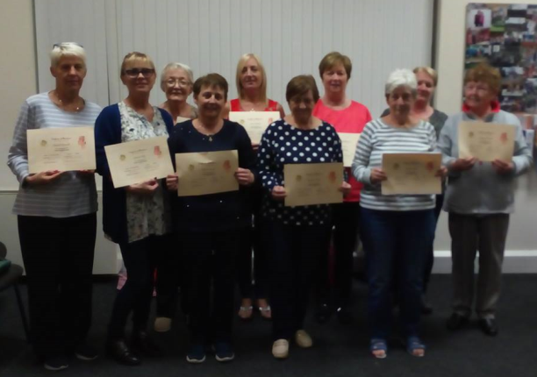

**Drug Misuse Service**

The Drug Misuse Service in WGRC provides an opportunity to engage in a process that helps the participant to identify what blocks them emotionally from making progress with their substance use or mental health issue. WGRC Drug Misuse Service offers a combination of different therapeutic and holistic interventions for those presenting with problem drug and alcohol use.

Participants who access the service are likely to use a combination of different drugs such as cocaine and its derivatives, tablets (valium, zimovane), stimulants, alcohol, opiates such as heroin and methadone, and cannabis in all forms.

A lot of the time it is word of mouth that brings new participants into the service, usually a friend or relative will have accessed the service and have had a positive experience in dealing with their addiction and recommend to others that they attend. In the past year there has been an increase in people attending with both addiction and mental health, and this has led to an increased demand on the service. Other source of referrals are from local GP’s, psychiatric & mental health services, local addiction services and local schools.

**One to One: Therapeutic Support**

We utilise a combination of different intervention models such as Cognitive Behavioural Therapy (CBT), Community Reinforcement Approach (CRA) and Motivational Interviewing (MI) within the service. The aim of using these varied interventions is to help the person to begin to change the drug or alcohol usage or to stop completely if that is what they want to achieve. It is also to explore the thought patterns that led to drug misuse and addictive behaviours in the past, and what effective strategies they can put in place, so as to ensure the risk of relapse diminishes in the future. The sessions are structured, goal oriented and focused on immediate problem solving.

Complementary therapies are another response to addiction or distress that the WGRC offers to those that attend the service. The therapies on offer include for example Reiki, Acupuncture, Holistic and Indian head massage as well as advice on the management of stress.

In 2018 the substance misuse counselling service was accessed by 114 participants. Of those who stayed with the process 78% reported making progress with improved emotional and physical well- being as well as reduced substance use be it drug or alcohol or a combination of substances.

Due to the robust assessment and case management process throughout the organisation the high ratio of non- attendance experienced in previous years was considerably diminished. Attendance was achieved in 79% of bookings in 2018.

\_\_\_\_\_\_\_\_\_\_\_\_\_\_\_\_\_\_\_\_\_\_\_\_\_\_\_\_\_\_\_\_\_\_\_\_\_\_\_\_\_\_\_\_\_\_\_\_\_\_\_\_\_\_\_\_\_\_\_\_\_

2017 2018

------------------------------------------------------------------------------

---------------------------------------------------------------------------------------------------------------------------------------

**Outcomes**

* + - 63 participants reduced or ceased substance use
    - 90 participants reported improved mental health
    - 34 reported improved physical well-being
    - 44 reported improved self- esteem and confidence
    - 55 reported improved quality of life

**Adolescent Support Service**

The adolescent support service is a direct response to a demand from parents, guardians, home school liaison officers, youth workers and young persons. The purpose of the project is to provide education and personal developments training to equip vulnerable young persons to acquire the skills, qualities and attitudes consistent with being resilient. It is envisaged that this intervention will enable the vulnerable adolescent to improve their mental health and better negotiate the stress and anxiety of their daily lives.

The Adolescent Support Service has been keenly embraced by local schools, with home school liaison officers being a principle source of referral. The service has engaged 16 adolescents throughout the year, ranging in age from 13 to 17 years.

**Our Approach**

Our approach is to build upon individual strengths and acknowledge the central role of the adolescent in decision making. The active participation of families is built into each intervention plan ensuring that our work makes lasting differences in the life of each adolescent we work with.

The service aims to intervene to provide the adolescent with the necessary supports to promote psychological resilience and maintain their psychological well-being regardless of social or emotional background. Anyone concerned about an adolescent aged between 12 and under 18 years can make a referral to the service.

The service involves the therapist working with the adolescent through many of the typical challenges of this life stage, such as exam stress, self- esteem issues, sexual identity and sexual exploration.

**Outcomes of Adolescent Support**

The aim of the project is to provide a wide range of supports and interventions that will

assist the target group. The following outcomes were identified in 2018;

* 9 participants reported an improvement in family relationships
* 3 participants reported greater integration within the community
* 4 participants reported the breaking down of isolation
* 12 participants reported a strengthening of their confidence and self-esteem
* 7 participants reported an improvement in social and interpersonal skills
* 9 participants reported greater self- awareness and personal development

**Family Support Service**

WGRC family support service has developed to support and respond to the needs of the family members who have been affected by substance misuse. Their concerns range from relationship difficulties to debt, intimidation, bereavement, loss and financial issues, etc.

*"I have found new ways to cope with stress and new ways to manage difficult situations through the support I have received from this group”*

Family members engaged in family support groups using the 5 step method. The 5 step method is a brief psychosocial intervention to support family members who have a close relative with an alcohol or drug problem. The family members participating in these groups reported a reduction in the strain they had been experiencing. Other benefits of the groups were improvements in coping mechanisms, increased self - esteem and strength, reduced stress levels and reduced negative patterns of behaviour.

"You learn very quickly that you are not alone and that the other members of the group will help you through the mess of drug addiction*"*

The family support groups are linked into the National Family Support Network which provides opportunities for networking with similar groups. The shared learning, exchange of information and respite this provides is of great benefit to the family support groups.

The WGRC family service offers one to one support as well as group support.

**Outcomes - One to One Support**

* 13 participants reported decreased negative patterns of behaviour
* 13 participants reported reduced stress levels
* 14 participants availed of respite opportunities
* 10 participants reported an improvement in family relationships
* 12 participants reported an increased understanding of addiction
* 11 participants reported improved living skills
* 10 participants reported reduced anxiety

**Group Based Support**

1 Women’s Creativity Group – 8 participants (all female)

1 Family Support Group – 16 participants (all female)

1 Mindfulness Therapy Group – 8 participants (2 male, 6 female)

1 Well Connected Mental Health Support – 10 participants (3 male, 7 female)

* 17 participants reported reduced stress levels
* 12 participants reported an increased knowledge of addiction
* 15 participants reported improved coping responses
* 14 participants reported enhanced social supports
* 12 participants reported reduced anxiety
* 10 participants reported improved family relationships
* 14 participants reported decreased negative patterns of behaviour

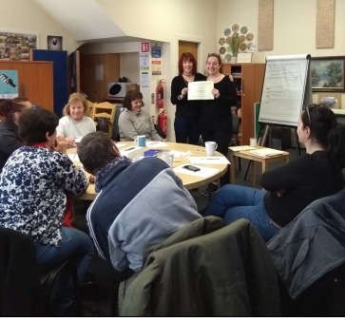

**Aftercare Support**

In 2018 the Aftercare service continued to provide support to a group of male participants (the SMART Group for females in hosted by ARC) who have decided to live a substance free lifestyle and need a safe environment in order to learn how to deal with life issues and share the struggle of staying substance free. The Aftercare group make use of the SMART Recovery approach which aims to increase choice in mutual aid options for people seeking abstinence from addictive behaviours. It is a mix of professional and peer-led meetings with its own governing body and national infrastructure.

Within the year a total of 10 males attended the SMART Aftercare groups.

**Women’s Creativity Group**

Following consultations with clients, it became apparent that a second Family Support Group was necessary to help them to deal with some of the issues that are going on within their families. combination of talking seriously about the struggle to live substance free as well as sharing the lighter side and generally just being around other like - minded individuals provided group members with an opportunity to connect with themselves and be seen by others in a different way. This provides a rich learning environment for the group members and strengthens the trust and group bond amongst members.

We started with developing the group, brain storming, working through talking, listening to each other and learning from one another. As the group jelled we looked at focusing on getting our wellbeing into a better place.

The group identified Healthy Eating as one of the places that they would like to start, the women soon realised that by eating well and following the food pyramid it helps with other medical problems, when we have a balanced diet we can focus better, sleep better and assists with improving our moods.

We looked at running an event for Mental Health Day Senator Máire Devine was our Key Note speaker and one of the members of the group spoke of her experience within the Metal Health system and how this group and service helped keep her alive. This event helped open the group to new members.

With new members we regrouped and put a plan in place for the coming months, this included mindful activities such as crafts, the women created Christmas Cards, Fairy Doors, Santa’s made from wood, a visit to the Men’s Shed and a Christmas table centre piece.

The Group also attended the Family Support National Conference and here they gained so much as they realised that they are not the only people in this situation they met with people from all over the country.

We have been awarded funding from the Community Foundation for Ireland to run a yearlong programme for Women and Wellbeing.

The group have great ideas for their future in 2019 we they will continue to meet and support each other.

**Well Connected –Drop-In Centre**

As participants presented with increasing mental health issues, we responded by providing a drop- in facility, 'Well Connected', which enabled participants to come together and offer mutual support and information on services and activities available. The "Well Connected" drop in space is modelled on the Gateway Project in Rathmines and aims to replicate the member led ethos of the organisation which identifies peer support for people with self- experience of mental health and recovery as crucial to its long- term success.

The "Well Connected" initiative aims to support the integration of people into the social, cultural, educational and working life of the community. It works to address social exclusion and disadvantage faced by many people with experiences of mental ill health and works in partnership to promote mental health wellbeing and recovery in the community.

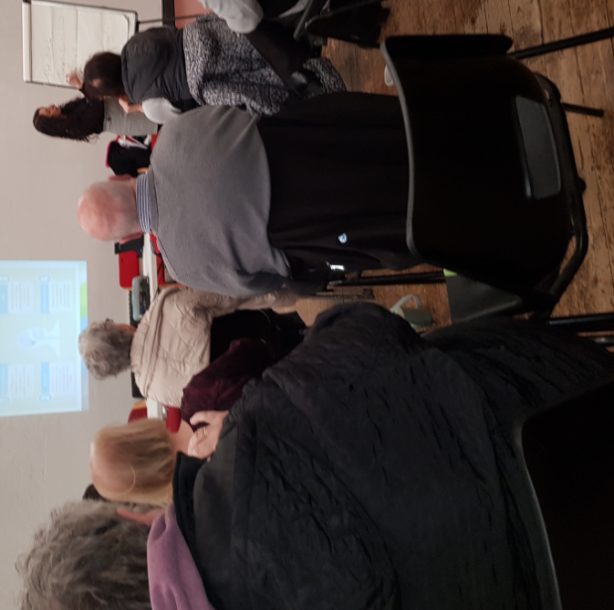

**WRAP – Wellness Recovery Action Planning**

WGRC ran a 6 week course in Wellness Recovery Action Planning (WRAP) as part of our mental health programme. This course was very well received and further WRAP sessions are planned throughout the coming year. The WRAP course was attended by 9 participants and helped those involved to**:**

* Discover their own simple, safe Wellness Tools
* Develop a list of things to do every day to stay as well as possible
* Identify upsetting events, early warning signs and using Wellness Tools develop action plans for responding to crisis situations.
* Be guided through the process of developing a Crisis Plan
* Introduce participants to Post Crisis Planning

**Feedback from Group Work Participants**

“I have got so much from coming to this group, I have learned to take better care of myself and to stand up for myself”.

“I find that my stress levels are always so much better when I share my problems with this group, I learn so much from being here”.

"The thing I’ve learnt most is that it is really up to me to change the things in my life that need changing, I have to be the one prepared to confront the negatives that are impacting on me, I shouldn’t expect some else to fix my life"

“I have got great support from this group, when I have been at my lowest, coming here every week has pulled my through, there are a lot of wise and wonderful people in this place”.

**MINDFULNESS - A Mindfulness Approach to Mental Health**

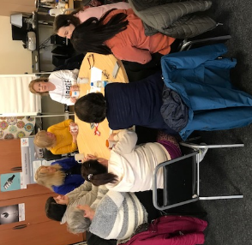As participants presented with increasing mental health issues, we responded by running a group support / intervention that enables participants to learn to cope with the many stresses in their lives. This approach fosters the capacity to observe, with an open, curious and non-judgmental mind, how stress and negative thoughts play out, moment by moment, in the body, thoughts and emotions.

This intervention is tailored to participants who typically have experienced trauma in their lives and may be struggling with mental health issues. It encourages participants to reside in the present moment, and to bring awareness to the consequences of their actions and to the 'story' that their minds persistently generate. With these skills, they are able to 'reframe' their past and present lives, building psychological safety, balance and resilience.

The group sessions encourage participants to be as present as possible to whatever is happening in the moment, rather than ignoring, suppressing, escaping or trying to conquer their physical or psychological pain. It is this unwavering focus on the present that promotes healing.

Following on from our Mental Health Day the community expressed an interest in doing a course in Mindfulness. The style we used for this is Mindful Based Cognitive Therapy. We set up our Holistic room with comfy chairs and blankets to set the scene for the best outcome.

We ran the course for six weeks and found there was a great uptake and two more six week courses followed giving more people in the community the opportunity to attend.

Over the six weeks we covered Breathing Exercises, Visualisation, Body Scans, and Meditation we encouraged the participants to use the Daily Mindfulness Practice. This proved very popular and will run further courses in 2019.

**D12 Men’s-Shed Development Group**

**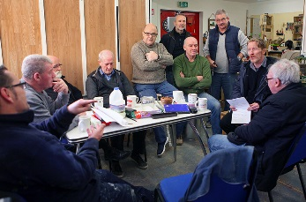**In the last year the D12 men’s-shed has grown from strength to strength and currently has 30 to 35 men accessing the shed on a regular basis for peer support and positive social interaction. Since the opening of the shed there has been great interest in the project and it has been promoted by the local church/ community & employment centres / addiction services in the wider D12 community.

The Shed has made it easier for men to seek and ask for support around their mental / emotional & physical needs. To date we have had a lot of men and their families from the shed access our Centre for counselling, support and information. The shed has provided men the space to talk side by side about their problems; it provides them with an avenue in which to get support and it gives them a space to contribute to their community by engaging in pro social activities such as making buddy-benches for the local schools and planters for the local community.

The men have also created contacts with other groups in the community and are also engaged in music / social outing groups as well as facilitating workshops with WALK clients. To date the Shed is self-sustaining and is run and organised by a committed shed committee who have taken over the daily running of the shed and continue to develop the Mens Shed.

In September 2018 the Mens Shed received funding from Ulster Banks Skills and Opportunities Fund to develop an enterprise project within the Mens Shed. This enabled many of the men to undertake further training in the areas of enterprise development, production and design and also provided funding to purchase additional tools and machinery, both of which have made a tremendous contribution to the development of the Mens Shed. The enterprise project is very much on target and is proving to be a very valuable part of the Mens Shed experience. The enterprise project will finish in September 2019.

**Young Person & Family Support Worker Initiative**

The Walkinstown Greenhills Resource Centre is of the view that very many families within the local community are suffering from the consequences of drug misuse, both directly and indirectly, and that parents and children (young persons) need the support of coordinated and integrated services to address their needs in relation to problem drug use.

With this in mind WGRC secured funding from TUSLA for a pilot initiative to employ a Young Person & Family Support Worker for the Walkinstown and Greenhills area. The worker was employed in October 2018, with the brief of developing a range of supportive interventions targeting the young person and / or family members at risk from the consequences of problem drug use within the Dublin 12 area.

**Supporting Families, Children and Young People at Risk**

Traditionally, drug treatment and rehabilitation programmes have focused solely on substance misusers, with family members receiving little if any attention. However, over recent decades, programmes increasingly have included a 'family component', reflecting a growing recognition of the important role families can play in the treatment and recovery of substance misusers.

The overarching philosophy of the Walkinstown Greenhills Resource Centre is that by providing the individual and their family with the appropriate intervention we build the capacity of the community to respond and bring about the desired change. This improvement for the individual changes the dynamic of the family in distress and in turn brings positive change for the community.

The intervention of a Young Person & Family Support Worker will enable very specific supports to be provided to those affected by familial substance misuse. These supports will draw upon well established and evidence based methodologies and programmes such as Parenting Plus, Strengthening Families, Incredible Years, ACRA (Adolescent Community Reinforcement Approach), 5 Step Model of Family Support, NVR (Non Violent Resistance), CBT (Cognitive Behavioural Therapy), Motivational Interviewing, 40 Developmental Assets, Mindfulness, Sure Start, Community Development and the Home Party Approach. This list is not extensive and is merely indicative of the range of evidenced based programmes that will be utilised.



There is now a strong body of evidence to indicate that there are very significant risk factors to problematic behaviours, such as drug use and other problematic behaviours, and it is the aim of this initiative to use this evidenced based information to target specific families and children in areas of social exclusion and disadvantage so that they can benefit from early intensive holistic and co-ordinated interventions. This form of targeting will ensure that those most at risk are targeted for interventions. This targeting must be subtle and sensitive to ensure that individual families and children are not stigmatised.

 In addition, this initiative will also provide for a range of capacity building measures in the form of training, workshops and the provision of resource material to frontline staff and volunteers engaged with those affected by familial substance misuse. The idea being that this will prove a game changer in the sense that support services will be well equipped to identify and respond to those affected by familial substance misuse at an early stage in the process and be in a position to intervene appropriately.

Further work will be undertaken with the provision of an additional 10% of overall funding being devoted to the ‘capacity development of staff directly associated with the delivery of this initiative. This will ensure that best practice is gleaned from the project and fed into the development and delivery of policy, provision and practice for children and young people. The Board and staff of WGRC look forward to learning about the outcomes of this initiative next year as funding will cease in June 2019.

**Strengthening Families Programme**

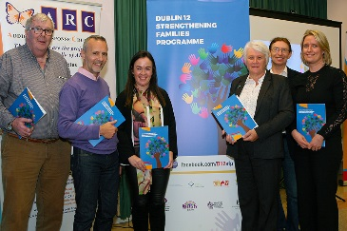

*Launch of SFP Evaluation Report 2018 by Minister Catherine Byrne*

The Strengthening Families Programme (SFP) is a comprehensive and intensive intervention delivered to families typically involving fourteen 2 hour sessions. In each session, groups of parents and adolescents meet separately initially for an hour, before then joining together for larger family group sessions. The evening begins with everyone sharing a meal together. The parent sessions focus on rules, communication, rewarding healthy behaviour and accessing supports in the wider community. The adolescent sessions focus on issues such as building positive expectancies, stress management and peer relationships. There is much empirical evidence to indicate both short and long term benefits from the SFP have been demonstrated to be cost effective. Although initially developed in the Unites States, the SFP has been implemented in a wide range of cultural settings.

The SFP is designed to address difficulties that arise in families, by increasing family strengths, young people and children's social competencies and improving positive parenting skills. Families who complete the SFP say they feel happier, closer and better able to cope with problems; they communicate better, talk more, spend more quality time together and are more resilient. These positive effects endure long after they have completed the SFP.

"The 17 year old was very quiet and withdrawn in himself and he was lacking in personal hygiene. After the group he’s come on in leaps and bounds…before, he wouldn’t mix. He was lacking in confidence. He would do anything for anyone else, but he didn’t care about himself. It made a huge difference for him" -Linda, SFP participant.

"He’s a totally different child. His empathy levels have hugely increased and he’s a lot calmer –Teacher of SFP child participant.

.

"There’s a whole lot of family time and bonding and relationship–building that happens, that wouldn’t happen if they didn’t do the programme”. - SFP Referrer & service provider.

"They’re the happiest three children coming home. Yeah, the difference in them coming home compared to going" –Sharon, SFP participant parent.

WGRC in collaboration with the Dublin 12 Drug & Alcohol Task Force and other stakeholders has been involved in the delivery and management of this programme since 2010. In 2018 the SFP was rolled out between September and December catering for 8 families, consisting of 15 children and 10 parents / guardians. The SFP requires that 6-8 trained facilitators are available from 3.30pm to 8.30pm, one day per week for 15 weeks, to deliver the programme and that a further 10-12 hours are devoted to the management of the programme through membership of the SFP Steering Committee. WGRC are pleased to support this programme, given its very clear and significant value to those who participate in it.

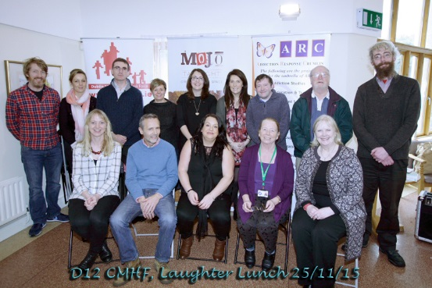 **Policy & Interagency Work**

Members of the Dublin 12 Community Mental Health Forum

The WGRC are actively engaged in the following policy and interagency working groups and Sub-committees of the Dublin 12 Local Drug and Alcohol Task Force.

* The Steering Committee of the Strengthening Families Programme
* The Steering Committee of the Dublin 12 Alcohol Strategy
* The Interagency and Collaboration Sub-Committee of D12 Task Force
* The Steering Committee of the FROST (Detoxification) Programme
* The Young Person & Family Support Worker Steering Committee
* The Dublin 12 Community Mental Health Forum

During 2018 support was given to and received from a wide range of agencies such as; Dublin 12 Local Drug & Alcohol Task Force, Addiction Response Crumlin (ARC); MABS; Citizens Information Centre, WALK; Local Schools; Loreto Counselling Service, Meitheal; TÚSLA; Local Gardaí; Local Health Care Professionals; the Dublin South City Partnership; the Jobs Initiative team; the Liberties Recycling Training Programme; the Local Employment Service; TUS, the Dublin Volunteer Centre, Local Dublin 12 Congress and Local Youth Organisations; the Brú, Clay, St. Bosco Youth Centre and Crumlin Youthreach.

**Governance**

Walkinstown Greenhills Resource Centre (WGRC) is constituted as a company limited by guarantee without a share capital. Its purpose, objectives and how it conducts its business are set out in its Constitution which establish the objects and powers of the company as governed by its Constitution and Board of Directors. During March 2018 the objects clause of WGRC’s Constitution was revised and approved by the board of Directors.

The Company is registered with the Charities Regulator and has charitable tax status with the Revenue Commissioners CHY 15712.

In order to maintain standards of best practise across all areas of our organisation, the Board and Management of WGRC adhere strictly to the recommendations outlined by the Charities Institute of Ireland and the Charity Regulator. We pay particular attention to, and comply with, the Statement of Recommended Practice for Accounting and Reporting by Charities (SORP), alongside the Governance Code and Fundraising Principles. WGRC recognises that active compliance is an ongoing and continuous task where, as an organisation, we seek to achieve constant standards of excellence.

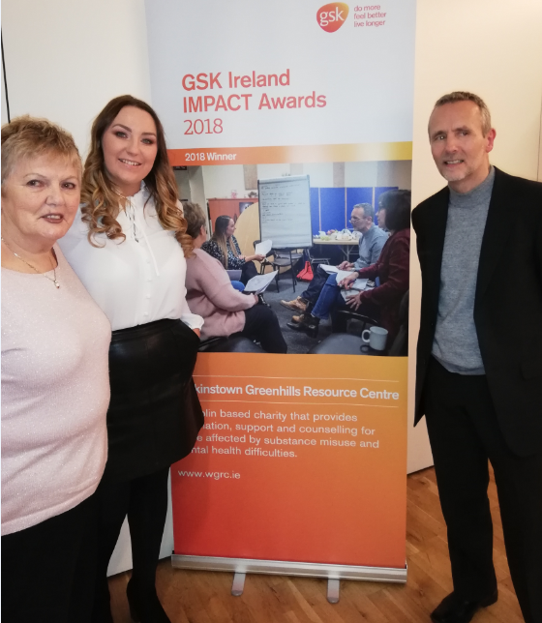

**STRUCTURE, GOVERNANCE AND MANAGEMENT**

The organisation is governed by a Board of Directors who work in a voluntary capacity. Directors do not receive any remuneration in respect of their service. No expenses were paid to directors in 2018. There have been no contracts or arrangements entered into during the financial year of material interest to a Director.

The Board of Directors met ten times during 2018 consisting of monthly board meetings, a specially convened meeting and an annual strategy review day. The board review day was supported by an external facilitator, with full participation that resulted in an output report that is reflected in the 2018 board agenda and work schedule.

In 2018 three standing sub committees were in place to support Directors to fulfil their governance responsibilities and duties. Board sub-committees comprise of Board Directors and external co-optee’s for expertise, when required.

**Sub-committees and membership 2018**

1. Audit and Risk: Suzanne McEneaney (Chair), Des Kinch (Secretary), Tracy Hunt (Administrator) and Kenneth O’Donnell (Board)
2. Funding and Finance: Suzanne McEneaney (Chair), Liz Bramble (Board), and John Davis (Manager)
3. HR and Staff Liaison: Bernadette Stokes (Chair), Vivian Mahady (Board), Emma Fox (Co-optee)

In addition the following Working Groups took place during 2018.

1. Quality & Safety Working Group- Liz Bramble, Suzanne McEneaney and John Davis.
2. Review of Company Objectives- Bernadette Stokes, Vivian Mahady, Suzanne McEneaney and John Davis.

**BOARD STANDING COMMITTEES**

Set within a culture of corporate governance review, in 2018 board directors agreed to establish a board self-evaluation process during 2018. Following a merger process involving our previous Auditors –Creely Fleming and Company- the board appointed Hugh McCarthy & Associates as our internal auditors. This resulted in a corporate governance assessment in 2018 with associated recommendations for board consideration of gender balance and age profile of new directors.

|  |  |  |
| --- | --- | --- |
| Board of Directors and Subcommittee meeting Attendance 2018 | Meetings Attended  (Eligible meetings in 2018) | Subcommittee Meetings Attended  (Eligible meetings in 2018) |
| Board Director |  |  |
| Bernadette Stokes (Chair) | 9 (10) | 8 (8) |
| Liz Bramble (Vice Chair) | 8 (10) | 2 (2) |
| Des Kinch (Secretary) | 7 (10) | 3 (3) |
| Suzanne McEneaney (Treasurer) | 9 (10) | 3 (3) |
| Vivian Mahady | 8 (10) | 2 (2) |
| Susan McAuley | 9 (10) | 6 (6) |
| Cornelia Horvath | 7 (10) | 2 (2) |
| Sean McMillan | 7 (10) | 3 (3) |
| Fintan Warfield | 6 (6) | 4 (5) |
| Tommy Coombes | 4 (4) | 2 (2) |
| Kenneth O’ Donnell | 8 (10) | 3 (3) |

**Achieving Compliance with the Governance Code**

In 2016 the WGRC Board of Management started the journey to compliance with the Governance Code, which is a voluntary code of good practice for the charity, community and voluntary sectors in Ireland. In 2018 we have implemented the elements outstanding in our journey to compliance and are delighted to announce that we have achieved our goal.

The Governance Code is a code of practice for good governance of community, voluntary and charitable organisations in Ireland. Governance refers to how an organisation is run, directed and controlled. Good governance means that an organisation will develop and put in place policies and procedures that will make sure the organisation runs effectively.

**The Audit & Finance sub-committee**

The role of the Audit and Finance Sub-committee is to inform policy at Board level and to ensure that the organisation operates in a transparent and accountable way by monitoring and reviewing company policy, procedures, financial controls and systems. This ensures that we operate in an efficient and effective manner. The sub-committee assess financial risks to the organisation as part of their remit and report and make recommendations to the Board.

**Charities Regulatory Authority & Charitable Tax Exemption**

The company has been granted charitable tax exemption by the Revenue Commissioners and are registered with the Charites Act 2009.

**Pay Scales**

Walkinstown Greenhills Resource Centre are a section 39 funded agency and as such, our pay policy has always been to pay salaries in line with HSE consolidated pay scales as much as possible. There are no employees whose total remuneration paid for the year (including taxable benefits in kind, redundancy payments and employer pension costs) exceeded €60,000.

**Board Review**

It is the role of the Governance Sub-committee to monitor and oversee both Board recruitment and performance. The Governance Sub-committee has carried out this role very effectively and further work on reviewing roles and responsibilities of board members will be undertaken in 2019. Reviewing the Board and Chairpersons performance is embedded as an essential part of good governance and the continuous development ethos of the whole service.

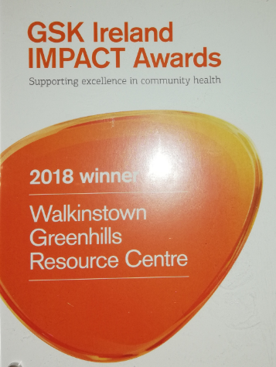

**WGRC Organisational Structure**

Board of Directors

Executive in Attendance

Sub-Committees

* Finance
* Governance

\_\_\_\_\_\_\_\_\_ \_\_\_\_\_\_\_\_\_\_

|

|

|

General Manager

Client Services Team Leader

Operations Team

Staff

|

|

|

\_\_\_\_\_\_\_\_\_\_\_\_\_\_\_\_\_\_\_\_\_\_\_\_\_\_\_\_\_\_\_\_\_\_\_\_\_\_\_\_\_\_\_\_\_\_\_\_\_\_\_\_\_\_\_\_\_\_\_\_\_\_\_\_\_\_\_\_\_\_\_\_\_\_\_

| | | | | | | |

Citizens Information

Adolescent Support

Keywork

Counselling

After-Care

Holistics

Mental Health Support

Family Support

**Organisational Structure**

**Walkinstown Greenhills Resource Centre**

**Board of Directors**

**Twelve Directors – 6 drawn from local development initiatives and 6 drawn from the local community**

**Student Counsellors:**

Monica Grogan

Don McLoughlin

Breda Gleeson

**Sessional Counsellors:**

Natalie May

Paul Gahan

Joe Bowden

**The Staff Team in 2018**

Manager: John Davis

Team Leader: Viv Rooney

Key Worker: Ann Nugent

Project Worker: John O’Donoghue

Project Worker: Jessica Keye

Project Worker: Mary Barnes

Youth Worker: Stuart Geelon

Financial Administrator: Tracy Hunt

Receptionists: Beatrice Finn/ Amanda McKeon

Caretaker: Martin Daly

**Sessional Team**

6 Counsellors and 1 Complementary Therapist

**Management & Administration Staff Team**

Manager: Administrator: Receptionists:

**Complementary Therapist**:

Sonya Keogh

**General Assistant:**

Patricia Kearney

**Walkinstown Greenhills Resource Centre CLG**

**CHAIRPERSON**  Bernadette Stokes

**TREASURER**  Suzanne McEneaney

**VICE CHAIRPERSON** Liz Bramble

**SECRETARY** Des Kinch

**DIRECTORS**

Vivian Mahady

Fintan Warfield

Susan McAuley

Jackie Byrne

Kenneth O' Connell

Tommy Coombes

Cornelia Horvath

Sean McMillan

AUDITORS Hugh McCarthy & Associates

Business Centre

163 Lower Kimmage Road

Kimmage

Dublin 6W

SOLICITOR Bourke & Company 167/171,

Drimnagh Road

Walkinstown

Dublin 12

BANKERS Bank of Ireland

Walkinstown

Dublin 12

COMPANY REGISTRATION NUMBER 334239

**INCOME & EXPENDITURE 2018**

2018 2017

**€ €**

Income 286,905 253,119

Expenditure (279,749) (249,068)

**------------ -------------**

**Surplus / (deficit) for the year** 7,156 4,051

Total Comprehensive Income 7,156 4,051

Non-Current Assets

Property, plant and equipment 6,996 3,341

Current Assets

Receivables 3,850 3,710

Cash and cash equivalents 105,720 33,893

-------------- -------------

109,570 37,603

-------------- --------------

**Payables: Amounts falling due within one year (70,066) (1,600)**

**--------------- -------------**

**Net Current Assets 39,504 36,003**

**Total Assets less Current Liabilities 46,500 39,344**

-------------- -----------

**Reserves:** Income Statement **46,500 39,344**

A separate Statement of Total Recognised Gains and Losses is not required as there are none other than those reflected in the Income and Expenditure Account.

**Acknowledgements**

The Board of WGRC would like to thank all the organisations and people who make it possible for us to provide services in Dublin 12. It could not be done without their help and support.

* Dublin 12 Local Drug & Alcohol Task Force
* The Health Service Executive
* ESB Energy for Generations Fund
* Ulster Bank
* TUSLA Child & Family Agency
* The Ireland Funds
* GSK Ireland
* Dublin South City Partnership / TUS
* Dublin City Council
* The Dublin 12 Community
* Dublin 12 Congress
* Voluntary fundraisers
* The Walkalaylies
* Local Community, Voluntary and Statutory Agencies
* WGRC Staff and Volunteers
* WGRC Participants

**THANK YOU!**

****qqob_h2t[1]